Top Ten Resources for additions to the AP HuG Syllabus- Part 2
by Sharon Shelerud

These sites will give you important information and will help you and your students understand some of the new concepts that were added to AP Human Geography.
I. Nature and Perspective
Identification of major world regions was added to the syllabus. These two sites identify the
major regions.
1. Reading: Internet World Stats - Usage and Population Statistics http://www.internetworldstats.com/list1.htm
Map of world regions: Flat world knowledge .com
http://images.flatworldknowledge.com/berglee/berglee-fig01_010.jpg
World regions based on UN Country Grouping
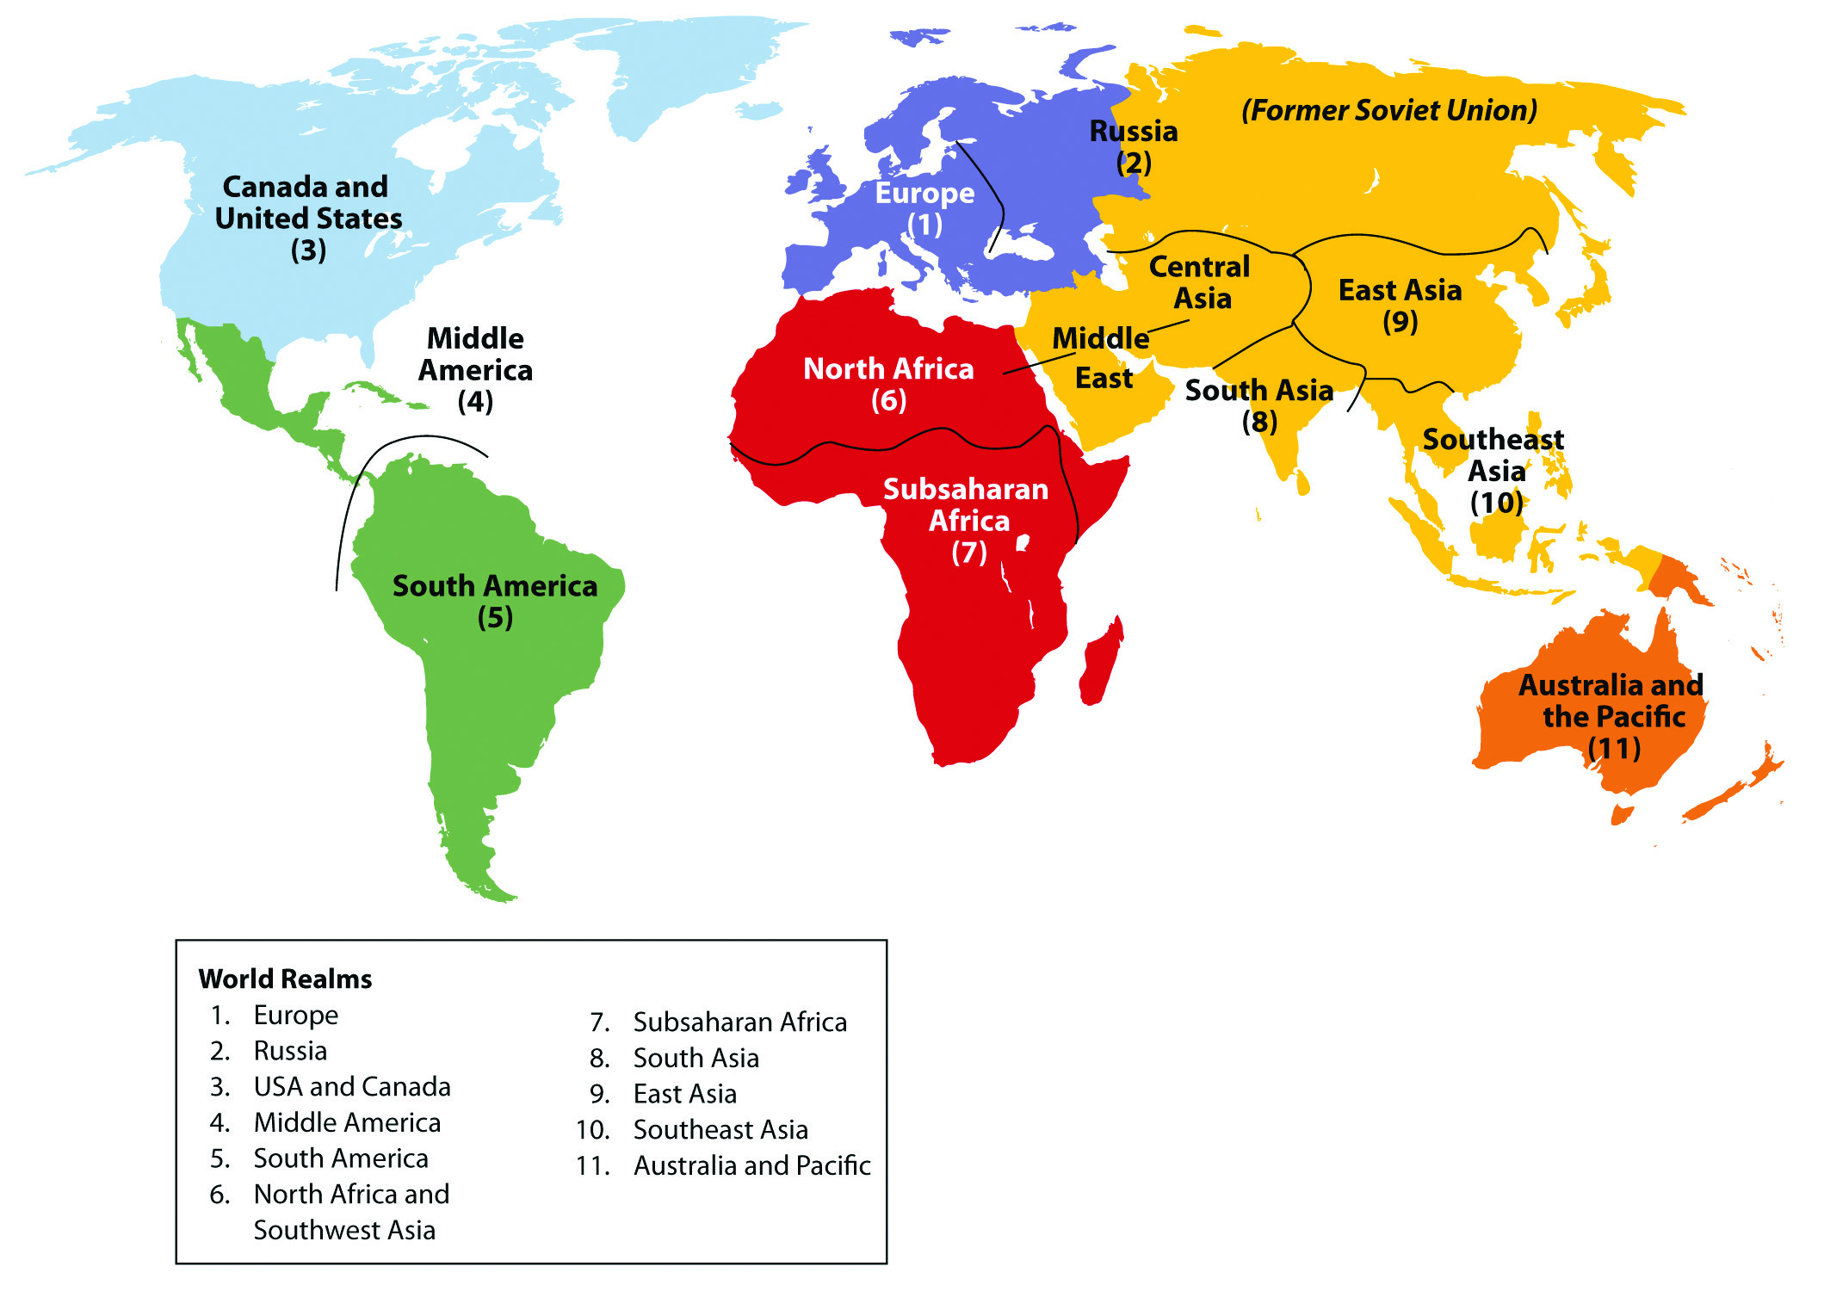
II. Population
One of the additions to migration was looking at cultural, environmental and political consequences of migration and immigration policies and remittances. These two sites mainly deal with immigration policies and remittances, but will also be helpful for the other consequences.
2. Types of migration
National Geographic -Xpeditions - Why People Migratehttp://www.nationalgeographic.com/xpeditions/lessons/09/g68/migrationguidestudent.pdf
Type of migration
Bednarz, Sarah, Texas A&M - "Migration"
http://geography.tamu.edu/class/sbednarz/geog201/migration8.html
3. Immigration policies and remittances
This link provides you with a variety of readings dealing with immigration policies and remittances.
http://scholar.google.com/scholar?q=immigration+policies+and+remittances&hl=en&as_sdt=0&as_vis=1&oi=scholart&sa=X&ei=Uv7oU5bhFsv5yQTV04GIBQ&ved=0CBsQgQMwAA
III. Culture
Students will need to know sacred spaces for religions. These two sites will be a good student resource.
4. Scared Destinations - Sacred spaces for world religions
Interactive Map http://www.sacred-destinations.com/maps/world-map
Patheos Library - is a website with a wide range of information regarding religion, including scared spaceshttp://www.patheos.com/Library/
The syllabus now specifies indigenous people under cultural landscapes and cultural identity. I would use this site as a student resource.
5. Indigenous peoples
International Work Group for Indigenous Affairs - http://www.iwgia.org/culture-and-identity/identification-of-indigenous-peoples
This website will help define and provide examples of indigenous peoples around the world.
IV. Political
ASEAN is now specified as an example of a regional alliance in the new syllabus. A great
resource to quickly get the information students will need.
6. ASEAN - Official site of the Association of Southeast Asian Nations
http://www.asean.org/
The new syllabus simply states function of boundaries. This could be interpreted in a variety
Of ways. This site will be helpful for teachers to prepare a student lesson on the topic.
7. Function of boundaries
Blake, Gerald. University of Durham, " Geographers and International boundaries".
https://www.dur.ac.uk/resources/ibru/publications/full/bsb7-4_blake.pdf
This site provides an overview of boundaries and geography along with explanations of how boundaries are used in geography. A very thorough document that would probably be best used as a teaching tool.
Case studies always help students understand concepts better. Dividing the class into small groups and jig sawing this article would benefit student learning.
Al Sayel, Mohammed, Lohma Peter , Heipke, Christian, "International Boundary making – Three case studies" - Indonesia and Timor, Nigeria and Cameroon, Saudi Arabia and Yemen.
http://www.isprs.org/proceedings/XXXVIII/1_4_7-W5/paper/Al_Sayel-123.pdf
This article is also a good review of how boundaries are made.
The new syllabus includes political ecology as a term. This site provides you with a working definition of political ecology.
8. Environmental Justice, Liberations and Trade
http://www.ejolt.org/2013/02/political-ecology/
Centripetal and Centrifugal forces were also included as terms to know in the political unit. This link provides you with working definitions and real world examples for both terms.
9. and 10. Lewis, Ken, "Centripetal and Centrifugal forces. " http://www.lewishistoricalsociety.com/wiki/tikiprint_article.php?articleId=146
Unit 5: Agriculture, Food Production and Rural Land Use
1. Students need to understand and identify agricultural types and the settlement patterns associated with each (subsistence, cash cropping, plantation, mixed farming, etc.). This site provides the best visuals for showing the different types of farming: www.wiley.com/college/kuby - (Human Geography in Action, 5th Edition [1] – student companion sites – Browse Resources – 8.1 Agricultural Landscapes).
2. “Food Production” is a new addition to this unit. Here is a game from National Geographic Education [2] that students can play to get them thinking about food production: http://education.nationalgeographic.com/education/media/planet-food/?ar_a=1
3. Fair Trade has also been added to the syllabus. Students can read about fair trade and some real world examples here: www.fairtradefederation.org [3]
4. This article from the LA Times [4] shows the dark side of large-scale commercial farming in Mexico. It could be used to show the role of women and children in agriculture too. http://graphics.latimes.com/product-of-mexico-labor/
5. A good food atlas is essential. Here is one from the U.S. Department of Agriculture [5] : www.ers.usda.gov/data-products/food-environment-atlas.aspx.
Unit 6. Industrialization and Economic Development
6. Rostow and Wallerstein have been specifically listed in the new syllabus. Most textbooks mention these two models, but do not go into enough depths for students to really understand them. Here are two resources that will be help students better understand these very important theories.
i. This site does a nice job of giving a more in depth explanation of Rostow’s Theory: www.yourarticlelibrary.com/economics/rostows-five-stages [6] . And here is a diagram.
ii. Here is a diagram showing Wallenstein’s World Systems Theory Model.
7. When companies shift manufacturing to newly industrialized countries, it can bring challenges as well as opportunities. Students can list the opportunities, but often don’t know what types of challenges there will be. To start a discussion on this I would suggest you have students read this article from USA Today [7] about Argentine’s economy: http://www.usatoday.com/story/news/world/2014/11/30/argentina-default-moving-to-united-states/18865583/
The CIA World Fact Book [8] would be very helpful in having students look up and better understand GDP, GDP per capita, and HDI, access to health care, education, utilities and sanitation.
Unit 7: Cities and Urban Land Use
8. You should teach Borchert’s epochs of urban transportation development. Here is a link to his article from the Geographical Review [9]: https://cascourses.uoregon.edu/geog471/pdfs/1206/borchert.pdf
I have students read this article and then the next day we discuss each of the epochs and create a chart showing the main elements of each epoch. When they get the article, they are overwhelmed by it, but after a day of two discussing it in class they understand it very well. Here is a site I just found that will help to reinforce his work: http://www.mnn.com/green-tech/transportation/stories/how-fast-could-you-travel-across-the-us-in-the-1800s [10]
9. You should discuss problems with urban sprawl. This article from The Atlantic will lead to an interesting discussion that will also bring in economic and demographic issues: http://m.theatlantic.com/business/archive/2014/11/the-unfinished-suburbs-of-America/382707/ [11]
10. The issue of segregation and housing is a major issue today. This web site will help students understand how “easy” it is to segregate. This game will be an excellent lead in to a class discussion on related issues: http://ncase.me/polygons/ [12]

