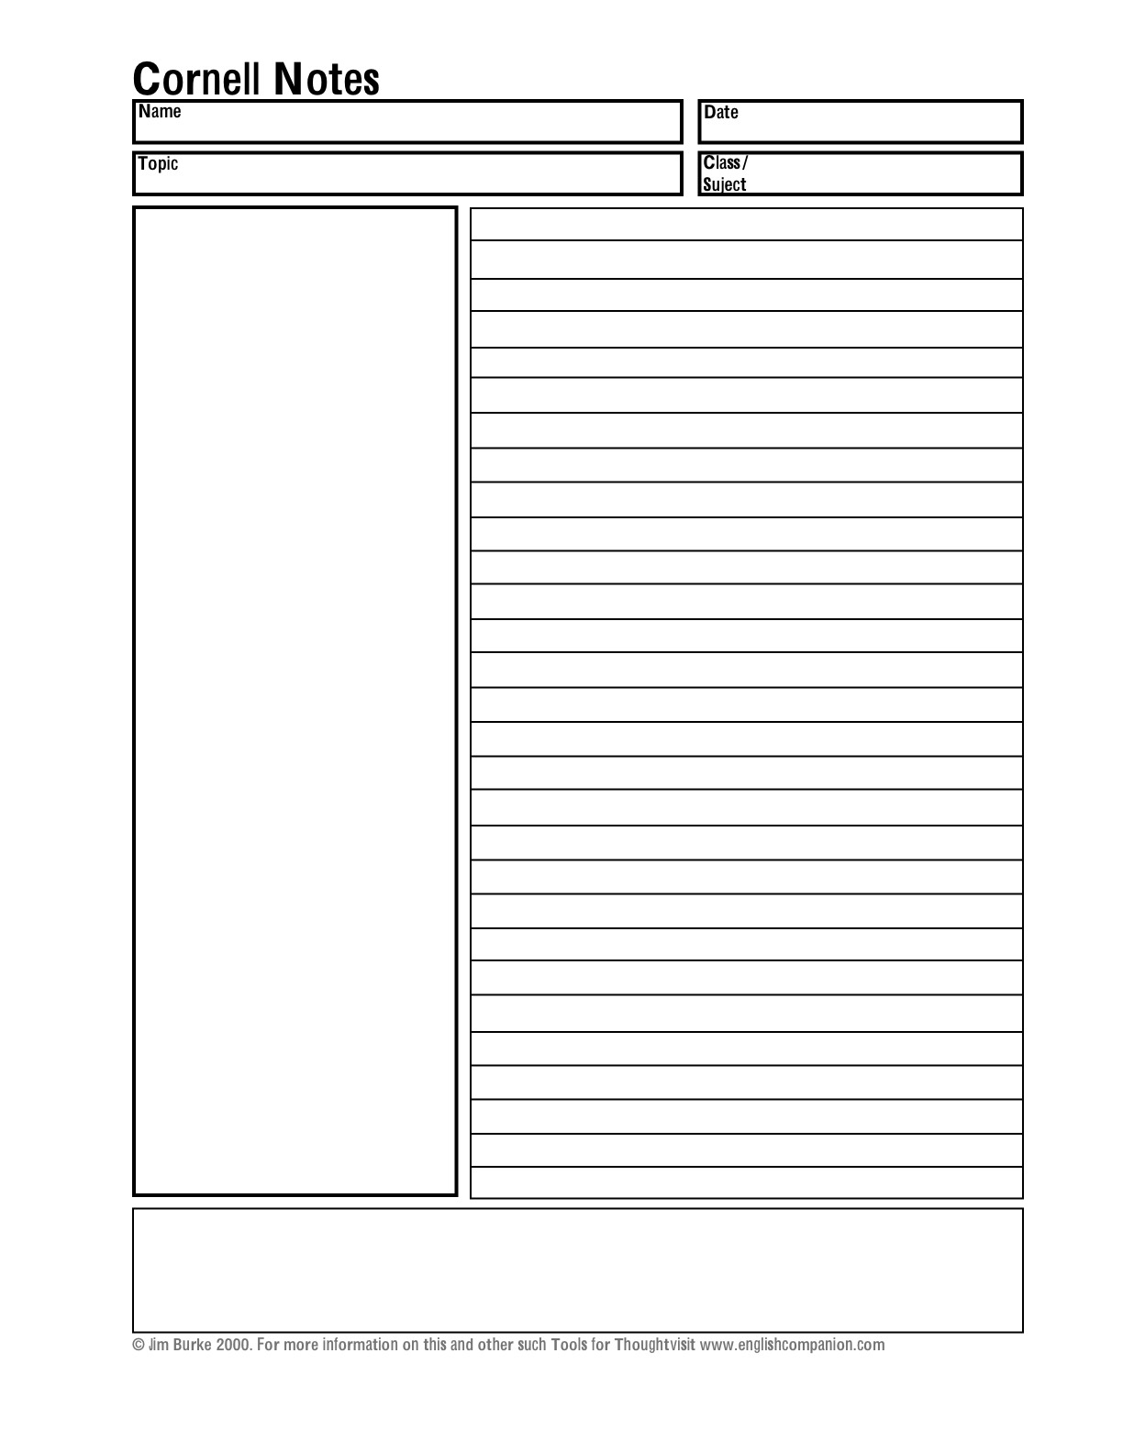

1. **Note Taking Area:** Record lecture or reading as fully and as meaningfully as possible.
2. **Cue Column:** As you’re taking notes, keep cue column empty. Soon after the lecture or reading, reduce your notes to concise jottings as clues for Reciting, Reviewing, and Reflecting.
3. **Summaries:** Sum up each page of your notes in a few sentences. What is the main idea.